MALWARE ANALYSIS REPORT
BillingApp.exe — Static Analysis

1. Sample Information
Field | Value
Sample | BillingApp.exe
Size | 28,216,596 bytes (~27 MiB)
SHA-256 | a7664b8ce3807c15a1e76384d6312eead5f5df3140c48a74dc7298e09f7acce7
MD5 | 5094d0ce132488b040e37a0503687963
Format | PE32+ / x86-64 / Windows CUI
Sections | 7
Execution status | NOT EXECUTED during static analysis

2. Executive Summary
- BillingApp.exe is a 64-bit Windows PE executable packaged with PyInstaller.
- The embedded application includes Python 3.14 runtime components, Flask, SQLAlchemy, SQLite, ReportLab, Waitress, and a React static frontend.
- Static analysis identified application-security weaknesses: a hard-coded Flask SECRET_KEY, a seeded admin/admin123 credential, and local storage of billing data and generated PDFs.
- No hard-coded external C2 URL/IP, persistence mechanism, ransomware behavior, or explicit credential-stealing logic was identified in the reviewed static evidence.
- Static analysis alone is not sufficient for a final malware verdict; controlled dynamic analysis in an isolated VM is required.

3. PE and Import Analysis

3.1 PE Header
Property | Value
Target machine | x64
Compilation timestamp | 2026-09-19 11:37:24 UTC
Entry point | 56560
Contained sections | 7
Highest observed section entropy | .rsrc — 7.350
Interpretation: The elevated .rsrc entropy is consistent with the large PyInstaller bundle and resources; entropy alone does not establish malicious packing.
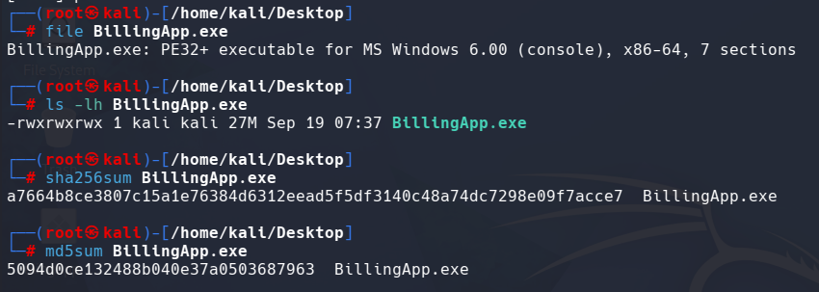

3.2 Imported DLLs
- USER32.dll
- KERNEL32.dll
- ADVAPI32.dll
Assessment: Process, file, environment, loader, and debugging-related APIs were observed. These can be normal in Python/PyInstaller runtime code and are not, by themselves, a malware verdict.

4. String and Packaging Analysis
- PyInstaller indicators identified: PYZ.pyz, _MEIPASS, _PYI_* variables, pyiboot01_bootstrap, python314.dll, and a CArchive cookie.
- Application strings indicate a local web application using localhost/127.0.0.1 and ports 5000/5173.
- Embedded modules include app, models, pdf_generator, Flask, SQLAlchemy, SQLite, ReportLab, Waitress, Pillow, OpenSSL libraries, and a React frontend.
- No external URL/IP associated with command-and-control was identified in the reviewed strings.

5. Application Security Findings
Finding | Evidence | Security Impact
Hard-coded secret | billing-system-secret-key-2026 | Weak Flask signing/session secret if used in production.
Default credential | admin / admin123 | High-risk default account; must be removed or changed.
Local database | billing.db / SQLite | Billing and customer information is stored locally.
PDF generation | Invoice PDF generation/download endpoints | Sensitive information could be exposed if authorization is weak.
Authentication surface | /api/login, /api/register, /api/logout, /api/me | Requires proper authentication and authorization controls.
Billing API | /api/bills and /api/bills/<id> | Requires strict authorization for invoice/customer data.

6. Malware-Behavior Assessment
Behavior | Static Evidence | Assessment
Persistence | No Run/RunOnce, scheduled task, service, or startup mechanism observed | Not observed statically
External C2 | No hard-coded external URL/IP observed | Not observed statically
Credential theft | No explicit credential-dumping behavior observed | Not observed statically
Ransomware | No ransomware extension/note or mass-file behavior observed | Not observed statically
Process injection | No clear injection API pattern established | Not established
Local web server | Flask/Waitress and localhost URLs | Observed
Local database | SQLite billing.db | Observed
PDF generation | ReportLab/invoice generation | Observed

7. Controlled Dynamic Analysis
- Use an isolated VMware Windows VM with a clean snapshot and host-only/internal networking.
- Disable shared clipboard, drag-and-drop, shared folders, and unnecessary host integration.
- Capture baseline process, network, and filesystem state before execution.
- Use Procmon to observe process creation, file activity, registry changes, and network-related activity.
- Use Wireshark or an isolated network emulation environment to observe DNS, HTTP, TCP, and UDP activity.
- After testing, export evidence, stop the process, revert to the clean snapshot, and re-check the sample hash.

8. Key Indicators / Evidence
Type | Indicator
SHA-256 | a7664b8ce3807c15a1e76384d6312eead5f5df3140c48a74dc7298e09f7acce7
MD5 | 5094d0ce132488b040e37a0503687963
Local URL | http://localhost:5000
Local URL | http://localhost:5173
Database | billing.db
Default account | admin / admin123

9. Countermeasures
- Remove the hard-coded Flask SECRET_KEY and use protected configuration or a secrets manager.
- Remove the seeded admin/admin123 account and enforce strong unique administrator credentials.
- Run the application with least privilege and restrict its listening interface/port.
- Enforce authorization on invoice/customer APIs, especially bill lookup and PDF download.
- Protect SQLite and generated PDF files with appropriate filesystem ACLs.
- Validate inputs and use parameterized database access.
- Keep Flask, Werkzeug, SQLAlchemy, ReportLab, Pillow, Python, OpenSSL, and other dependencies patched.
- Code-sign production executables and verify signatures/hashes during deployment.
- Enable EDR and centralized logging for process creation, network connections, and file modifications.
- Keep malware-analysis samples isolated from corporate networks.

10. Final Assessment
Assessment: Based on the reviewed static evidence, BillingApp.exe is more consistent with a PyInstaller-packaged billing/web application than a conventional standalone malware payload. The main identified risks are application-security weaknesses, particularly the hard-coded secret and default credentials. No external C2 indicator or persistence mechanism was established statically. A final malware determination requires controlled dynamic analysis and, where appropriate, code/dependency review.

Appendix A — Selected Analysis Evidence
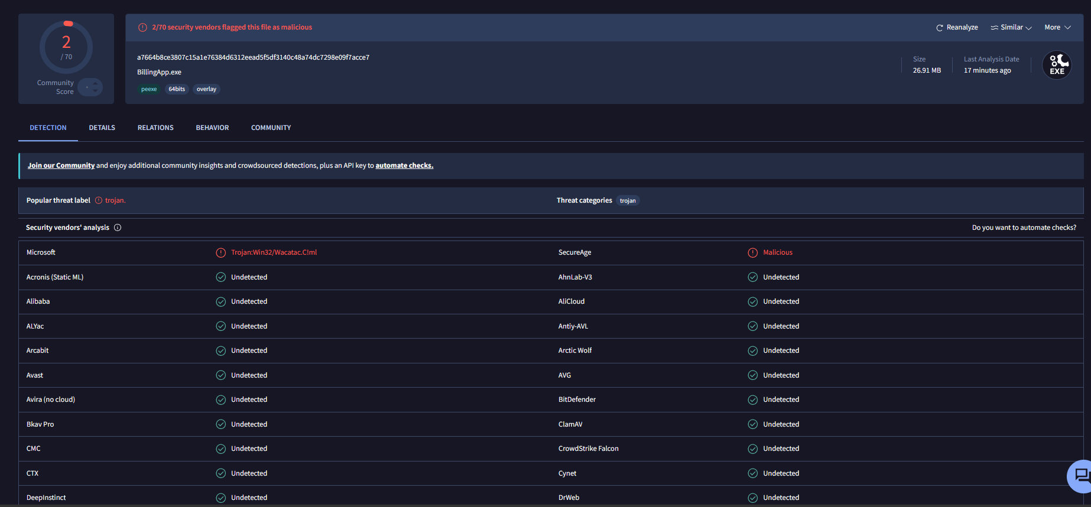
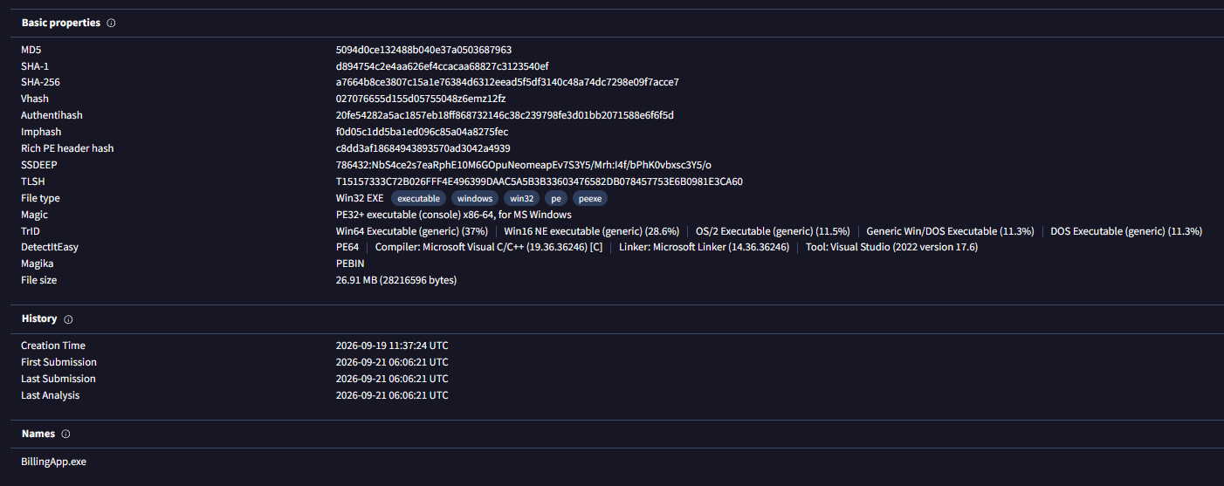
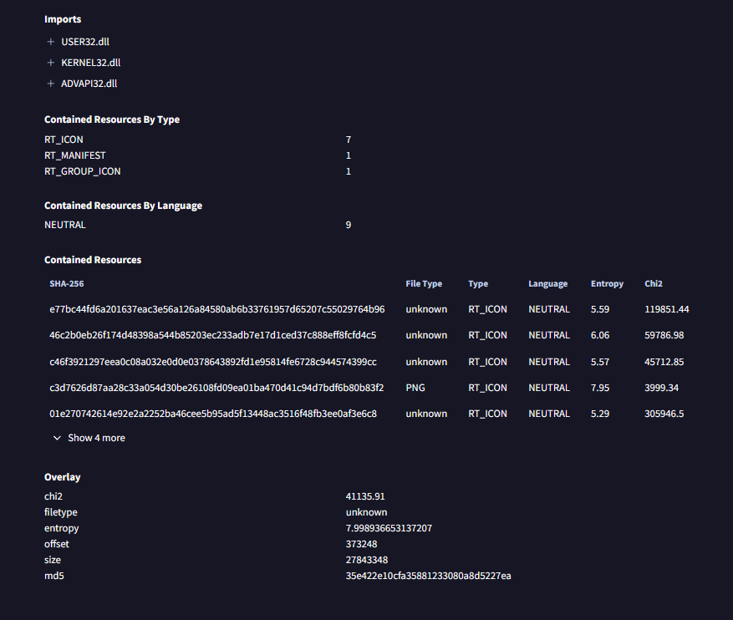
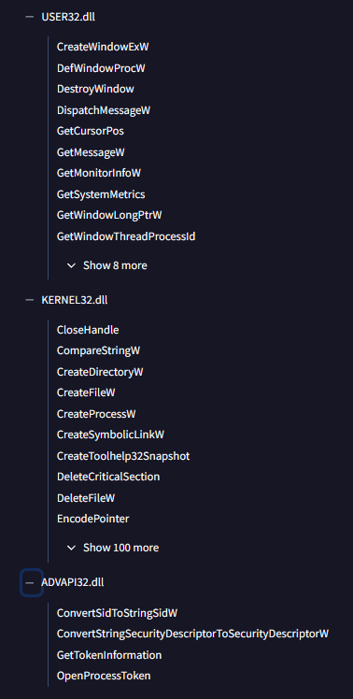

Hashes after Executing .EXE application in VMware/windows 10
